|  |  |  |
| --- | --- | --- |
| **Kingdom of Saudi Arabia**  **Ministry of Education**  **Bisha University**  **Faculty of Computers and IT** | **Image result for bisha university** | **Information System Department**  **Master in Cybersecurity**  **Biometric Systems**  **SYS 616** |

**A Short Technical Report in**

A Convolutional Neural Network for IRIS Recognition

**Supervisor(s)**

Dr. Mostafa Ahmad

Assistant Professor in Computer Science Department

**Author(s)**

Wael Ghazi Ahmed Alnahari

**Final Practical Report**

April 2020

TABLE OF CONTENTS

Abstract iv

Introduction 1

1.1 Introduction to CNN 1

1.2 CNN Architecture 2

Implementation of cnn for biometric recognition 3

2.1 Data Set 3

2.2 Layers 4

2.3 Training Options 5

results 6

3.1 Training Trails 6

3.2 Final Accuracy 7

3.3 Samples of Identification Results 8

Appendix: Matlab code 9

References 10

# Abstract

# Introduction

.

## Introduction to CNN

## CNN Architecture

categories = {'001','002','003','004','005','006','007','008','009','010','011','012','013','014','015','016','017','018','019','020','021','022','023','024','025','026','027','028','029','030','031','032','033','034','035','036','037','038','039','040','041','042','043','044','045','046','047','048','049','050','051','052','053','054','055','056','057','058','059','060','061','062','063','064','065','066','067','068','069','070','071','072','073','074','075','076','077','078','079','080','081','082','083','084','085','086','087','088','089','090','091','092','093','094','095','096','097','098','099','100','101','102','103','104','105','106','107','108','109','110','111','112','113','114','115','116','117','118','119','120','121','122','123','124','125','126','127','128','129','130','131','132','133','134','135','136','137','138','139','140','141','142','143','144','145','146','147','148','149','150','151','152','153','154','155','156','157','158','159','160','161','162','163','164','165','166','167','168','169','170','171','172','173','174','175','176','177','178','179','180','181','182','183','184','185','186','187','188','189','190','191','192','193','194','195','196','197','198','199','200','201','202','203','204','205','206','207','208','209','210','211','212','213','214','215','216','217','218','219','220','221','222','223'};

num_train = 7*223;

num_test = 3;

imdsTrain = imageDatastore(fullfile(pwd,"TrainData", categories),'IncludeSubfolders',true,'FileExtensions','.bmp','LabelSource','foldernames');

img = readimage(imdsTrain,1);

[x , y] = size(img);

inputSize=[x y 1];

% imdsTrain=augmentedImageDatastore(inputSize, imdsTrain,'ColorPreprocessing','rgb2gray');

% I = imread(imdsTrain.Files{1});

% [x , y] = size(I);

% for i=1:size(imdsTrain.Files,1)

% I = imread(imdsTrain.Files{i});

% [a b c]=size(I);

% if c>1

% I = rgb2gray(I);

% end

% I = imresize(I, [x y]);

% imwrite(I, imdsTrain.Files{i});

% end

%% Load Test Data

imdsValidation = imageDatastore(fullfile(pwd,"TestData", categories),'IncludeSubfolders',true,'FileExtensions','.bmp','LabelSource','foldernames');

% imdsValidation = augmentedImageDatastore(inputSize, imdsValidation,'ColorPreprocessing','rgb2gray');

% A = imread(imdsValidation.Files{1});

% for i=1:size(imdsValidation.Files,1)

% A = imread(imdsValidation.Files{i});

% [a b c]=size(A);

% if c>1

% A = rgb2gray(A);

% end

% A = imresize(A, [x y]);

% imwrite(A, imdsValidation.Files{i});

% end

%

%% Calculate the number of images in each category.

labelCount = countEachLabel(imdsTrain);

# Implementation of cnn for biometric recognition

## Data Set

Description of the IITD Iris Image Database version 1.0

=======================================================

This iris image database mainly consists of the iris images collected from the students and staff at IIT Delhi, India. This database has been acquired in

the Biometrics Research Laboratory during January - July 2007 using JIRIS, JPC1000, digital CMOS camera. The acquired images were saved in bitmap format.

The database of 2240 images is acquired from 224 different users and made available freely to the researchers. All the subjects in the database are in the

age group 14-55 years comprising of 176 males and 48 females. The resolution of these images is 320 x 240 pixels and all these images were acquired in the

indoor environment. All the images in the database were acquired from the volunteers who were not paid or provided any honorarium. The images were acquired

using an automated program that requires users to present their eyes in a sequence until ten images are registered.

Organization of Database

========================

The acquired database is saved in 224 folders, each corresponding to 224 subjects. Majority of images were acquired from the left eyes while the rest images

were acquired from right eye. Now the database has a label 'L' or 'R' which designates left or right eye. There are 1288 images from 224 subject that are from

left eyes while the rest images from 211 subjects are from right eyes.Except folders 1-13, 27, 55 and 65 all other folders have five left and 5 right eye

images. (**appended on 20-04-2016**).

Usage of Database

========================

This database is only available for research and noncommercial purposes. Commercial distribution or any act related to commercial use of this database is strictly

prohibited. Kindly acknowledge all the publicly available publications/work employing this database with the following acknowledgment:

"Portions of the work tested on the IITD Iris Database version 1.0"

A citation to "IIT Delhi Iris Database version 1.0, http://web.iitd.ac.in/~biometrics/Database_Iris.htm

Related Publication:

====================

Ajay Kumar and Arun Passi, "Comparison and combination of iris matchers for reliable personal identification," Proc. CVPR 2008, Anchorage, Alaska, pp. 21-27 Jun. 2008

Contact Information:

====================

Ajay Kumar

Biometrics Research Laboratory

Indian Institute of Technology Delhi

New Delhi, India

E-mail: ajaykr@ieee.org

## Layers

layers = [

imageInputLayer([x y 1]);

convolution2dLayer(3,8,'Padding','same')

batchNormalizationLayer

reluLayer();

maxPooling2dLayer(5,'Stride',2)

convolution2dLayer(3,16,'Padding','same')

batchNormalizationLayer

reluLayer();

averagePooling2dLayer(5,'Stride',2)

convolution2dLayer(3,16,'Padding','same')

batchNormalizationLayer

reluLayer();

maxPooling2dLayer(5,'Stride',2)

convolution2dLayer(3,32,'Padding','same')

batchNormalizationLayer

reluLayer();

averagePooling2dLayer(5,'Stride',2)

convolution2dLayer(3,32,'Padding','same')

batchNormalizationLayer

reluLayer();

fullyConnectedLayer(223,'BiasLearnRateFactor',2);

softmaxLayer

classificationLayer];

## Training Options

options = trainingOptions('sgdm', ...

'InitialLearnRate', 0.0001, ...

'ValidationData',imdsValidation, ...

'ValidationFrequency',30, ...

'Shuffle','every-epoch', ...

'MaxEpochs', 94, ...

'MiniBatchSize', 8, ...

'ValidationFrequency',50, ...

'LearnRateSchedule','piecewise', ...

'LearnRateDropFactor',0.05, ...

'LearnRateDropPeriod',60, ...

'ExecutionEnvironment','parallel', …

'Verbose', true, 'Plots','training-progress');

# results

## Training Trails

## Final Accuracy

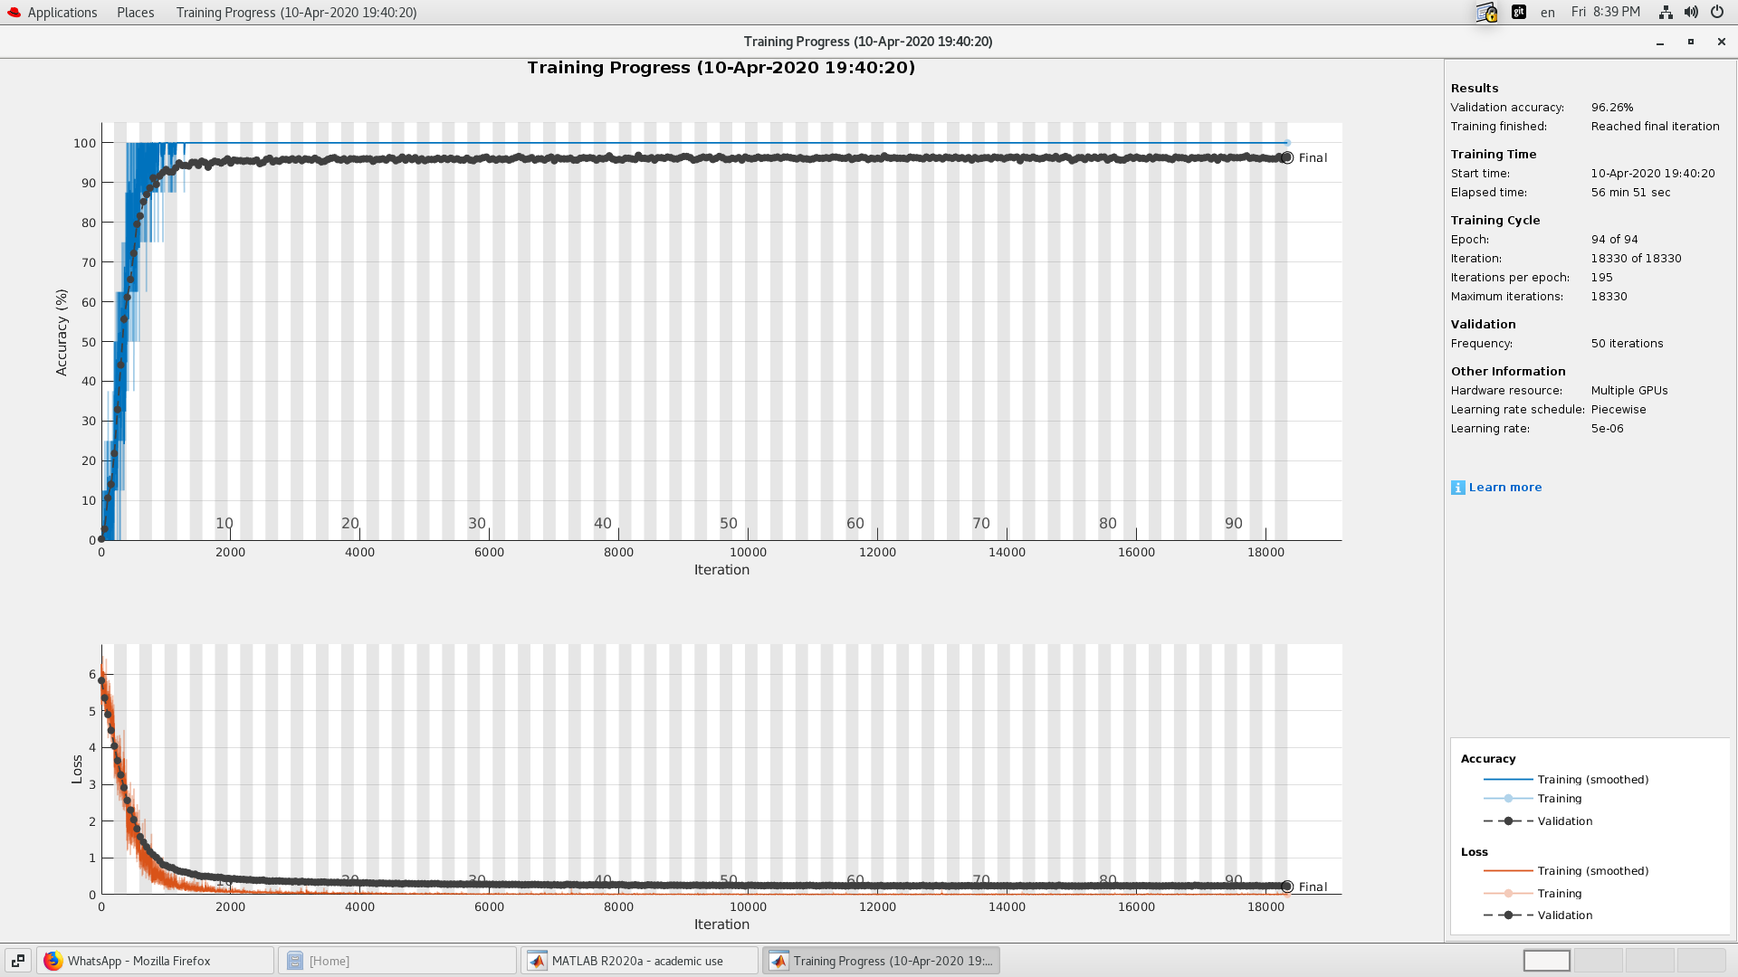

## Samples of Identification Results

# Appendix: Matlab code

**CNN Code for Biometric Recognition**

% Biometric Systems

% CYS616

% Wael Ghazi Ahmed Alnahari

% 440804845

% Dr. Mostafa Abdel-Halim Mostafa Ahmad

% A CONVOLUTIONAL NEURAL NETWORK FOR IRIS RECOGNITION

clc; % Clear the command window.

close all; % Close all figures (except those of imtool.)

clear; % Erase all existing variables. Or clearvars if you want.

workspace; % Make sure the workspace panel is showing.

reset(gpuDevice(1)); % Reset GPU memory

%% Load train Data

categories = {'001','002','003','004','005','006','007','008','009','010','011','012','013','014','015','016','017','018','019','020','021','022','023','024','025','026','027','028','029','030','031','032','033','034','035','036','037','038','039','040','041','042','043','044','045','046','047','048','049','050','051','052','053','054','055','056','057','058','059','060','061','062','063','064','065','066','067','068','069','070','071','072','073','074','075','076','077','078','079','080','081','082','083','084','085','086','087','088','089','090','091','092','093','094','095','096','097','098','099','100','101','102','103','104','105','106','107','108','109','110','111','112','113','114','115','116','117','118','119','120','121','122','123','124','125','126','127','128','129','130','131','132','133','134','135','136','137','138','139','140','141','142','143','144','145','146','147','148','149','150','151','152','153','154','155','156','157','158','159','160','161','162','163','164','165','166','167','168','169','170','171','172','173','174','175','176','177','178','179','180','181','182','183','184','185','186','187','188','189','190','191','192','193','194','195','196','197','198','199','200','201','202','203','204','205','206','207','208','209','210','211','212','213','214','215','216','217','218','219','220','221','222','223'};

num_train = 7*223;

num_test = 3;

imdsTrain = imageDatastore(fullfile(pwd,"TrainData", categories),'IncludeSubfolders',true,'FileExtensions','.bmp','LabelSource','foldernames');

img = readimage(imdsTrain,1);

[x , y] = size(img);

inputSize=[x y 1];

% imdsTrain=augmentedImageDatastore(inputSize, imdsTrain,'ColorPreprocessing','rgb2gray');

% I = imread(imdsTrain.Files{1});

% [x , y] = size(I);

% for i=1:size(imdsTrain.Files,1)

% I = imread(imdsTrain.Files{i});

% [a b c]=size(I);

% if c>1

% I = rgb2gray(I);

% end

% I = imresize(I, [x y]);

% imwrite(I, imdsTrain.Files{i});

% end

%% Load Test Data

imdsValidation = imageDatastore(fullfile(pwd,"TestData", categories),'IncludeSubfolders',true,'FileExtensions','.bmp','LabelSource','foldernames');

% imdsValidation = augmentedImageDatastore(inputSize, imdsValidation,'ColorPreprocessing','rgb2gray');

% A = imread(imdsValidation.Files{1});

% for i=1:size(imdsValidation.Files,1)

% A = imread(imdsValidation.Files{i});

% [a b c]=size(A);

% if c>1

% A = rgb2gray(A);

% end

% A = imresize(A, [x y]);

% imwrite(A, imdsValidation.Files{i});

% end

%

%% Calculate the number of images in each category.

labelCount = countEachLabel(imdsTrain);

%% Define Network Architecture

layers = [

imageInputLayer([x y 1]);

convolution2dLayer(3,8,'Padding','same')

batchNormalizationLayer

reluLayer();

maxPooling2dLayer(5,'Stride',2)

convolution2dLayer(3,16,'Padding','same')

batchNormalizationLayer

reluLayer();

averagePooling2dLayer(5,'Stride',2)

convolution2dLayer(3,16,'Padding','same')

batchNormalizationLayer

reluLayer();

maxPooling2dLayer(5,'Stride',2)

convolution2dLayer(3,32,'Padding','same')

batchNormalizationLayer

reluLayer();

averagePooling2dLayer(5,'Stride',2)

convolution2dLayer(3,32,'Padding','same')

batchNormalizationLayer

reluLayer();

fullyConnectedLayer(223,'BiasLearnRateFactor',2);

softmaxLayer

classificationLayer];

%% Specify Training Options

options = trainingOptions('sgdm', ...

'InitialLearnRate', 0.0001, ...

'ValidationData',imdsValidation, ...

'ValidationFrequency',30, ...

'Shuffle','every-epoch', ...

'MaxEpochs', 94, ...

'MiniBatchSize', 8, ...

'ValidationFrequency',50, ...

'LearnRateSchedule','piecewise', ...

'LearnRateDropFactor',0.05, ...

'LearnRateDropPeriod',60, ...

'ExecutionEnvironment','parallel',...

'Verbose', true, 'Plots','training-progress');

%% Train Network Using Training Data

[net_Wael, info] = trainNetwork(imdsTrain,layers,options);

save net_Wael

%% Classify validation

labels = classify(net_Wael,imdsValidation);

%% *Test one at a time*

for i=1:223

ii = randi(num_test*2);

im = imread(imdsValidation.Files{ii});

figure, imshow(im);

if labels(ii) == imdsValidation.Labels(ii)

colorText = 'g';

else

colorText = 'r';

end

title(char(labels(ii)),'Color',colorText);

end

%% Compute Accuracy

YValidation = imdsValidation.Labels;

accuracy02 = sum(labels == YValidation)/numel(YValidation);

display(accuracy02);

# References

Books

1. Harnack, Andrew, and Eugene Kleppinger. *Online! A Reference Guide to Using Internet Sources.* 3rd ed. New York: St. Martin’s Press, 2000.

Parts of a Books

2. Ashbrook, James B., and Carol Rausch Albright. “The Frontal Lobes, Intending, and a Purposeful God.” Chap. 7 in *The Humanizing Brain*. Cleveland, OH: Pilgrim Press, 1997.

Periodicals

3. Cook, Alison. “Phoenix Rising.” *Gourmet*, April 2000, 62–64.

Reports

3. Dempsey, B. *Climatic Effects of Airport Pavement Systems: State of the Art.* Report DOT2DRD-75-196. Washington, DC: Federal Highway Administration, US Department of Transportation, 1976.

Theses and Dissertations

4. Murphy, Priscilla Coit. “What a Book Can Do: *Silent Spring* and Media-Borne Public Debate.” PhD dissertation, University of North Carolina, 2000.

Papers Presented at Meetings

5. Nass, Clifford. “Why Researchers Treat Online Journals Like Real People.” Keynote address, annual meeting of the Council of Science Editors, San Antonio, TX, May 6–9, 2000.

Online Sources

6. Stevens, R. C. Testimony before United States Senate Special Committee on the year 2000 technology problem. 1998. http://www.senate.gov/~y2k/statements/ 091098stevens.html.